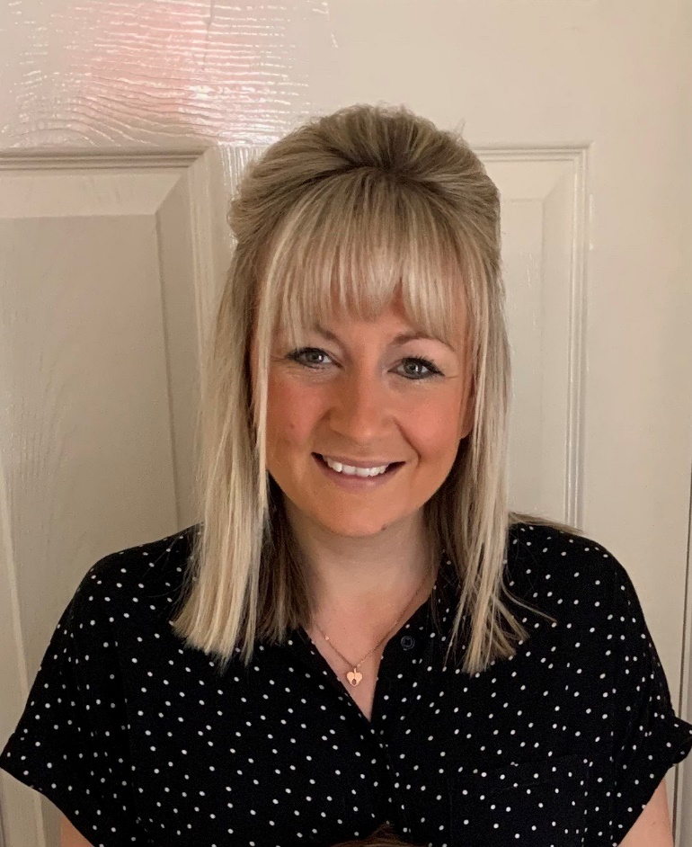

**Mrs Jeffs – Early Years Foundation Stage Leader**

Hi, my name is Mrs Jeffs and I am one of the Reception Teachers here at Hoole as well as the Early Years Foundation Stage Leader. I started teaching at Hoole Church of England Primary back in 2010 and believe that Hoole really is a special place. When I first started teaching I was originally a teacher in Year 1. However, my heart has always been in Early Years education and, after a couple of years, I decided I wanted to teach the youngest children in our school. I absolutely love teaching in Reception, the children’s minds are full of curiosity and motivation and they learn so much through their environment and through play. When you come and visit us, you will probably see me with my Ipad, capturing lots of wonderful learning that takes place.

I absolutely love reading stories to the children in school, one of my particular favourites has to be ‘We’re Going on a Bear Hunt’ by Michael Rosen. I really like it when the children join in and we put lots of different actions to it!

As well as being a teacher, I am also a mummy to two little boys, Jack who is 6 and Harry who is 3. As a family, we are regular visitors to Chester Zoo and we thoroughly enjoy going on long walks along the beaches in North Wales.

I cannot wait to meet you all and I am thoroughly looking forward to getting to know you!

